AWS Hyperscaler Overview

Cloud Strategy and Architecture Impacts

for

Cloud Dynamic Architecture and Technology

Author(s): Beth Layton, Michael Hill

Classification: Cloud Dynamic Architecture and Technology offering team

Kyndryl internal use only when complete

Document History

Document Location

This is a snapshot of an on-line document. Paper copies are valid only on the day they are printed. Refer to the author if you are in any doubt about the currency of this document.

Revision History

|  |  |  |  |  |
| --- | --- | --- | --- | --- |
| **Revision Number** | **Revision Date** | **Name** | **Summary of Changes** | **Changes marked** |
|  |  |  |  |  |
|  |  |  |  |  |
|  |  |  |  |  |
|  |  |  |  |  |
|  |  |  |  |  |

Approvals

The following persons have approved this document:

|  |  |
| --- | --- |
| **Name** | **Date** |
| Cloud Architecture Design Review Board |  |
|  |  |

Contents

1. Introduction 6

1.1 Purpose 6

1.2 Scope 6

1.3 Intended Audience 6

1.4 Key resources 6

1.5 How to Find the Latest Version of this Document 7

2. AWS overview 8

2.1 Kyndryl differentiators 8

3. AWS approach to cloud strategy 9

3.1 AWS Cloud Adoption Framework 10

3.2 Perspectives 10

3.2.1 Business Perspective 11

3.2.2 People Perspective 11

3.2.3 Governance Perspective 12

3.2.4 Platform Perspective 12

3.2.5 Security Perspective 13

3.2.6 Operations Perspective 13

4. Aligning our Kyndryl approach with the AWS CAF 14

4.1 Strategy 15

4.1.1 Gathering input about the client 15

4.1.2 Assessing Application Disposition 16

4.1.2.1 AWS 7Rs 16

4.1.2.2 Kyndryl 7 Rs 16

4.1.2.3 Mapping of AWS dispositions to Kyndryl disposition 17

4.1.3 AWS tools that support building a strategy 18

4.1.3.1 AWS Cloud Adoption Readiness Tool (CART) 18

4.1.3.2 Migration Readiness Assessment (MRA) 19

4.1.3.3 Application Discovery Service 20

4.1.3.4 Migration Portfolio Analysis (MPA) 21

4.1.3.5 Migration to AWS 23

4.1.3.6 AWS tool summary 23

5. AWS approach to architecture 24

5.1 AWS Architecture Center 24

5.2 AWS Well-Architected Framework 24

5.2.1 AWS Well-Architected Lenses 25

5.3 AWS Well-Architected (WA) Tool 26

5.4 AWS reference architectures and best practices 26

5.5 Aligning our cloud architecture offering to AWS 27

5.5.1 Client engagement example 27

5.5.2 AWS repository 27

5.5.3 Infrastructure as Code (IAC) tools 28

List of Figures

Figure 1 AWS Flywheel 9

Figure 2 Elements that help the AWS flywheel spin 9

Figure 3 : AWS Cloud Adoption Framework Overview 10

Figure 4 AWS Cloud Adoption Framework Perspectives 11

Figure 5: Business Perspective 11

Figure 6: People Perspective 12

Figure 7: Governance Perspective 12

Figure 8 Platform Perspective 12

Figure 9 Security Perspective 13

Figure 10 Operations Perspective 13

Figure 11: The AWS perspective on driving cloud adoption 14

Figure 12: AWS elements of a successful journey 15

Figure 13 Kyndryl definitions of the76Rs 17

Figure 14 Mapping of Kyndryl dispositions to AWS dispositions 18

Figure 16 MRA Readiness Assessment Heatmap 20

Figure 17 Navigation Pane of the Migration Portfolio Assessment 22

Figure 18 AWS Well-Architected Tool - how it works 26

# Introduction

This document provides an overview of AWS differentiators, mindset, and approach to strategy and planning and the associated architecture requirements for transformation.

As a practitioner, you may be asked to work on a project where the client has pre-selected AWS. This means that you must put on your “AWS hat” to represent the AWS approach accurately and execute the engagement the way the hyperscaler and its partner certification team want it to be performed. This is a critical aspect to providing services for hyperscalers. To achieve, maintain or increase Kyndryl partner status with a hyperscaler we must demonstrate compliance with their approaches such as the Cloud Adoption Framework, Well-Architected Framework etc. The AWS approach links people, process and technology and requires both strategy and architecture to address these dimensions.

That said, hyperscalers want their partners to differentiate themselves; not be cookie cutters. For example, we need to share our best practices (and vice versa) and collaboratively work together to develop an accurate and compelling strategy and architecture for the client.

## **Purpose**

The purpose of this document is to highlight similarities and differences relative to approaching cloud strategy and transformation across Kyndryl for AWS and any supporting AWS tools. This information is our interpretation of the AWS mindset and approach to analyzing the migration to cloud and is based on review of available training and documentation.

## Scope

The scope of this document is aimed at providing a high-level introduction to the Amazon approach for cloud adoption and how it impacts our cloud strategy and transformation and architecture engagements. This is to be used as a supplement to the material we provide on [Transformation Strategy and Roadmap](https://kyndryl.box.com/s/yxeg0hrmwvc3nydut9lit2iqrapqgyqt), [Cloud Technology Strategy and Roadmap](https://kyndryl.box.com/s/h32y3mv26kzz483y0zubbkc2swo30fcr), or [Cloud Technology Architecture](https://kyndryl.box.com/s/pnlrvd3ffzfrs5bdabuazgitzhqk25m0) engagements.

## Intended Audience

The primary audience of this document is practitioners supporting Cloud Architecture Design engagements.

## **Key** resources

Material in this document was developed by reviewing training and documentation available from AWS from public sites and from the partner network. There are many links throughout this deck to AWS whitepapers, tools and information.

**AWS:** They Kyndryl AWS page is here: [Kyndryl Services for AWS - Kyndryl Services for AWS Cloud](https://w3.ibm.com/ocean/w3publisher/kyndryl-aws/) and slack channel is #kyndryl-aws.

To further prepare to perform with AWS, you must attain the requisite certifications. Reference the Kyndryl AWS site for certification information. Beyond this training and certification, you will most likely need to be mentored by an experienced certified AWS architect on one or more engagements to gain the requisite analysis knowledge and skills.

For Kyndryl there are additional internal materials to help understand AWS and Kyndryl positioning and the partnership approach. The following documents and links are the best starting points:

* [Kyndryl AWS site](https://w3.ibm.com/ocean/w3publisher/kyndryl-aws) with cross-Kyndryl information for AWS engagements
* Kyndryl SIH Cloud Solutioning Guild [Hyperscaler Solution Design Resources](https://w3.ibm.com/ocean/w3publisher/sih-cloud-solutioning/hyperscaler-resources) pages where you can expect to see a growing library of hyperscaler solutions and material
* [AWS POV deck](https://kyndryl.box.com/s/c76evxkk9iy757cfyc7fhrriaun7fu2e) – MD&I perspective on approaches to market and adoption of AWS cloud services (INTERNAL USE ONLY)
* [AWS partner playbook](https://ibm.seismic.com/Link/Content/DCpLbmmU6l40COUflrqbNyCw) - including certification paths
* [APN info](https://partnercentral.awspartner.com/APNSelfRegister) – AWS partner network and access to resources
* For sellers and external facing material please also see the [AWS Resource Hub on Seismic](https://ibm.seismic.com/Link/Content/DCKYIaF3cj1keyssIZRKtmlQ)
* For Kyndryl-AWS architecture method and work product guidance please start with section 5.5 of this document.

**Note:** As you review these materials, you’ll see that we’re operating under the existing IBM-AWS partnership agreement. Details of the Kyndryl-AWS partnership agreement will be shared on the Kyndryl Services for AWS Cloud website as it becomes available.

For current information on the Kyndryl-AWS partnership please review #kyndryl-aws and #kyndryl-hypersclaer-readiness Slack channels.

## How to Find the Latest Version of this Document

The user of this document is responsible for using **only** the current revision. The document will be located in the Cloud Architecture Design box structure, under the Cloud Technology Strategy & Roadmap assets: <https://kyndryl.box.com/s/fr0sz8k0byr4zhnn59ah5e8tza3hovxc>

# AWS overview

The AWS approach to cloud adoption is referenced via their Cloud Adoption Framework (CAF), which is explained in Section 3 below. Most clients will have read the Cloud Adoption Framework, so it is critical that you understand the terminology used and are consistent with it.

In line with the Cloud Adoption Framework, AWS also provides some tools that AWS provides via partners. You will see upon reading the AWS CAF that they support six areas or perspectives and teach the importance of organizational change and governance. However, their tools and guidance are mostly around how to migrate and architect AWS solutions. Their goal is to get the client on AWS quickly and learn from this. They expect their partners to use AWS best practices and to supplement with their own experiences and expertise.

## Kyndryl differentiators

Our cloud strategy and transformation practice is mature. If the client is focused on AWS, we want to use and embrace AWS tools and best practices but also add value above and beyond.

With our approaches, such as Transformation Strategy and Roadmap we provide an **in-depth capability** to define the clients cloud transformation approach and build a roadmap. We can easily plug AWS tools and terminology in to supplement an AWS only engagement.

The AWS approach is focused on migration. While their assessments touch upon capturing what can be modernized as well – their focus is on migration and getting workloads onto AWS as fast as possible. While they touch upon the other facets, e.g., organization, culture etc. and deem them critical, not much else besides high-level guidance is provided.

In addition, AWS documentation assumes (or would like) everything is going to AWS. They really don’t focus on the enterprise client where some workloads may still be on the mainframe, on Z, or just in a data center. We add value when we can have those tough conversations on hybrid cloud and how it would operate.

Lastly, our automation and AIOps capabilities are more advanced than AWS or another hyperscaler; we should promote our capabilities and experience in these areas.

# AWS approach to cloud strategy

The [Amazon Flywheel](https://fourweekmba.com/amazon-flywheel/) (Figure 1) or Amazon Virtuous Cycle is a business strategy that leverages customer experience to drive traffic to the platform and third-party sellers. This improves the selections of goods, and Amazon further improves its cost structure so it can decrease prices which spins the flywheel. The concept behind this strategy is that a flywheel demands considerable efforts at the beginning, and once the wheel starts spinning, it continues to gain momentum and revolve faster swiftly.

This flywheel is also applied to the cloud part of their business. Applied from a cloud perspective, this means that price decreases are automatic for some of their cloud pricing models, driving the clients to the platform. Most importantly, when you optimize any part of the flywheel, it makes an impact on other components as well; accelerating the entire process.

According to Jeff Wilke, CEO of Amazon Worldwide Consumer, this idea was first sketched by Jeff Bezos back in 2001 and has been Amazon’s marketing strategy for years. This is an Amazon mindset -- a way to seize opportunities within industries, where inefficiencies are the rule. At the same time, it helps speed up growth by investing as much as possible in customer experience.

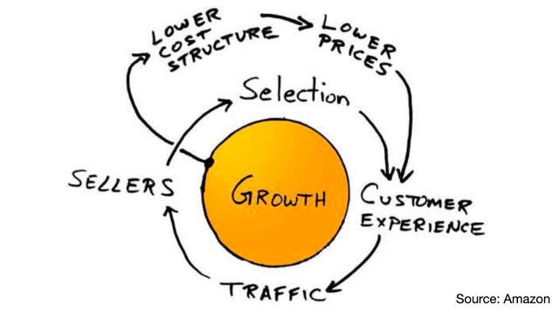

Figure 1 AWS Flywheel

AWS has built a reputation on their ability to establish benchmarks across ~1500 customers and discuss associated case studies. Their success with cloud has led to many “marketing” benchmarks that are attractive (but not achievable in every situation). That said, cost optimization is an integral theme in their sales and solution approach.

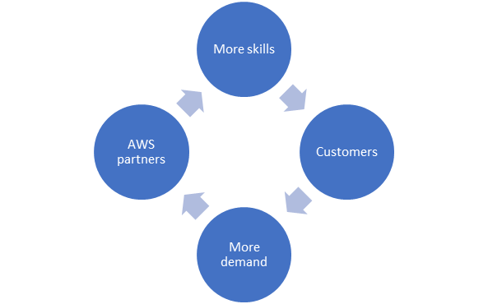

This flywheel approach isn’t only about cost optimization with AWS. It could be applied to partners, skills etc. The more pervasive AWS is, the more it continues the acceleration of the flywheel.

Figure 2 Elements that help the AWS flywheel spin

## AWS Cloud Adoption Framework

At a high level, the [AWS Cloud Adoption Framework](https://aws.amazon.com/professional-services/CAF/) (AWS CAF) moves from envisioning the future to measuring business value as shown in Figure 2.

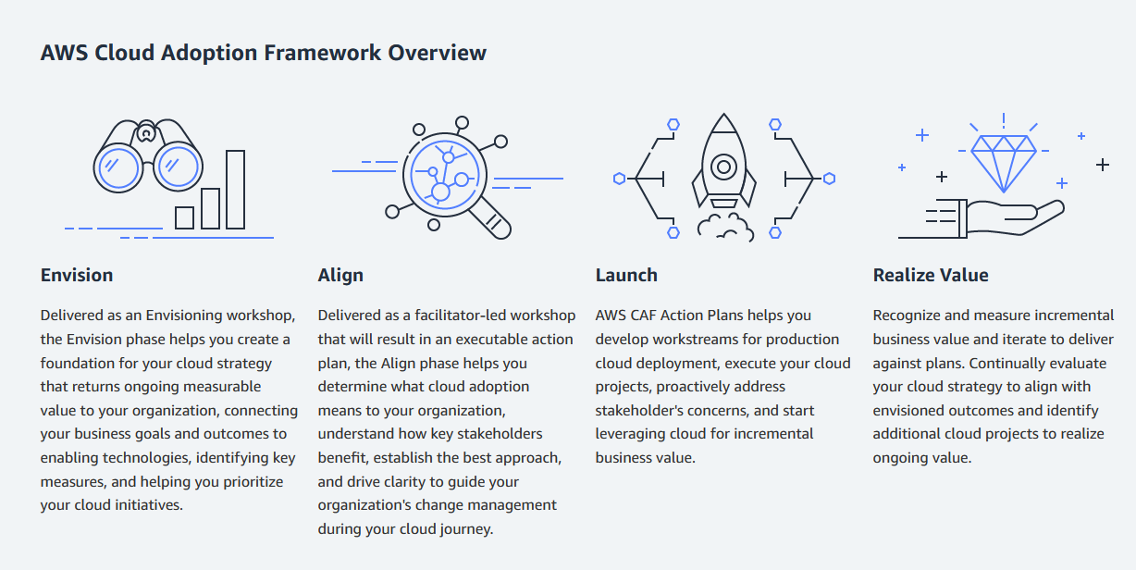

Figure 3 : AWS Cloud Adoption Framework Overview

AWS recommends a three-phase approach to help customers successfully migrate to cloud:

1. Assess
2. Mobilize
3. Migrate and Modernize

The AWS Cloud Adoption Framework is there to demonstrate how organizations can align their cloud strategies and goals to their business strategies and goals. It is a framework that helps organizations identify the gaps in their current organizational capabilities and devise work streams to close those gaps.

## Perspectives

The AWS CAF focuses on six areas of focus called perspectives (Figure 3). These perspectives cover distinct responsibilities owned or managed by functionally related stakeholders. In general, the Business, People, and Governance Perspectives focus on business capabilities; while the Platform, Security, and Operations Perspectives focus on technical capabilities. The CAF is the approach to be implemented to successfully move to cloud.

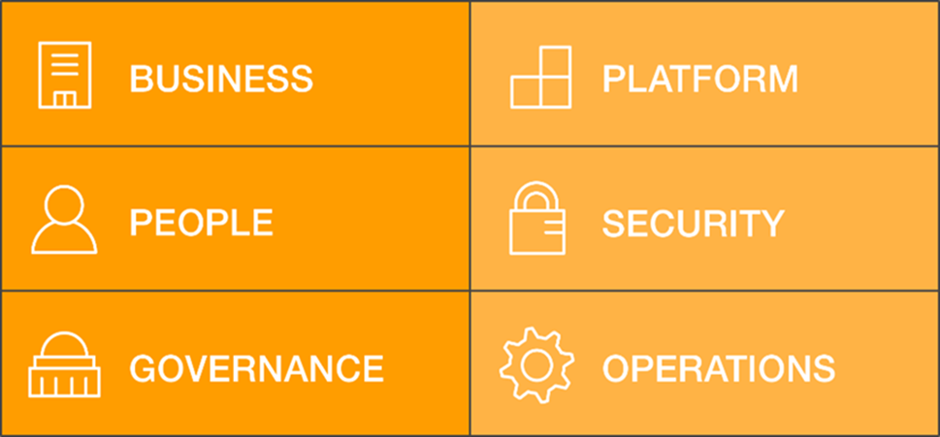

Figure 4 AWS Cloud Adoption Framework Perspectives

### **Business Perspective**



AWS CAF Business Perspective Capabilities

The business perspective is focused on the alignment of the business and IT needs, along with tracing IT investments back to business results.

This is where business case, relating IT and business strategy come in to play. Areas such as cloud objectives, risk management and portfolio management fit here. Much of this should be captured upfront in the engagement – to ensure the cloud strategy supports the business objectives and can be realized.

Figure 5: Business Perspective

### **People Perspective**

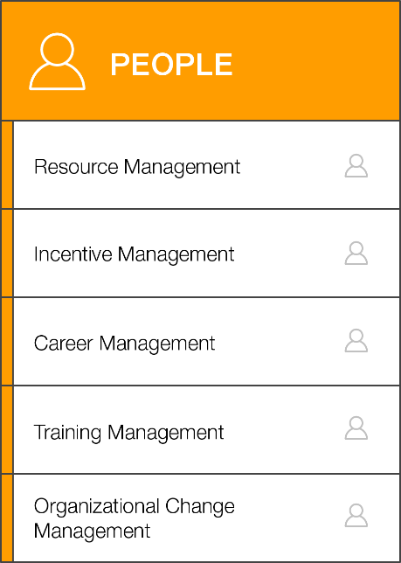People, organization, and culture is a critical element of any AWS strategy. Within this perspective, AWS incorporates a key concept of a CCoE.

Per AWS:

*“It is important to develop a critical mass of people with production AWS experience as you prepare for a large migration. Establish operational processes and form a Cloud Center of Excellence (CCoE) that’s dedicated to mobilizing the appropriate resources. The CCoE will lead your company through organizational and business transformations over the course of the migration effort. A CCoE institutionalizes best practices, governance standards, automation, and drives change throughout the organization. When done well, a CCoE inspires a cultural shift to innovation and a change-is-normal mindset.”*

The people perspective is focused on cloud- based competencies, communications, and organizational readiness. It is critical that any cloud strategy understands where the client is today with the people dimension and has short and longer-term initiatives to advance them.

Figure 6: People Perspective

### **Governance Perspective**

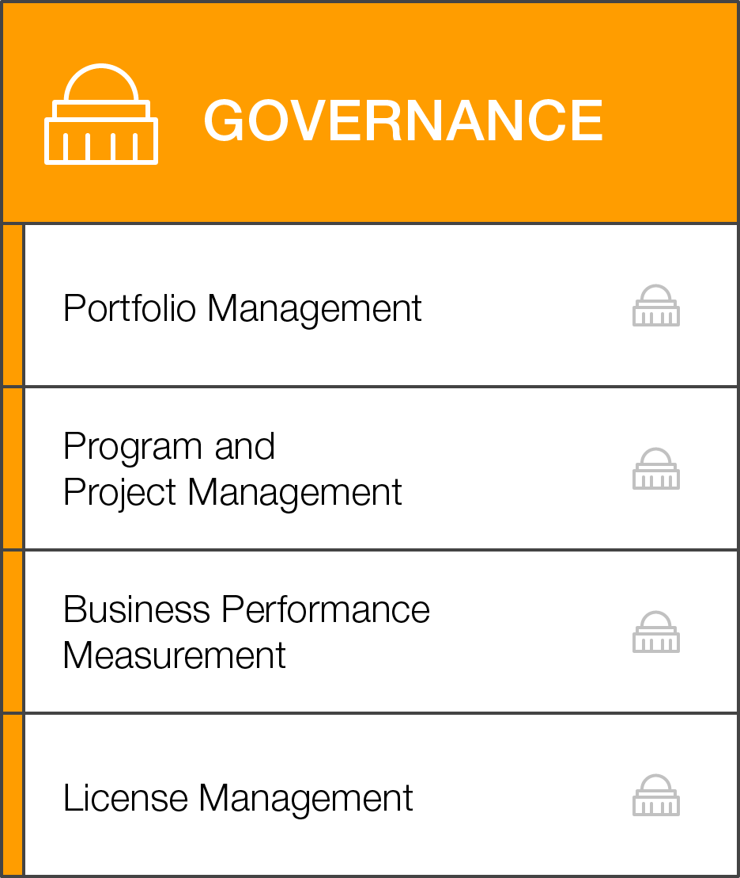Governance means many things to many people. In the AWS CAF, governance focuses on the skills and processes needed to align IT strategy and goals with the organization’s business strategy and goals -- to ensure the organization maximizes the business value of its IT investment and minimizes the business risks.

The governance perspective is focused on ensuring business governance and compliance. It is also focused on managing and measuring cloud investments and evaluating business outcomes.

Figure 7: Governance Perspective

### **Platform Perspective**

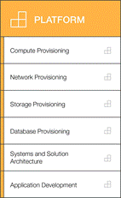The platform perspective is focused on the provision applications and infrastructure on the cloud and optimizing services and solutions in the cloud. The perspective focuses on the technology and the workloads and how they will look in the AWS environment.

Figure 8 Platform Perspective

### **Security Perspective**

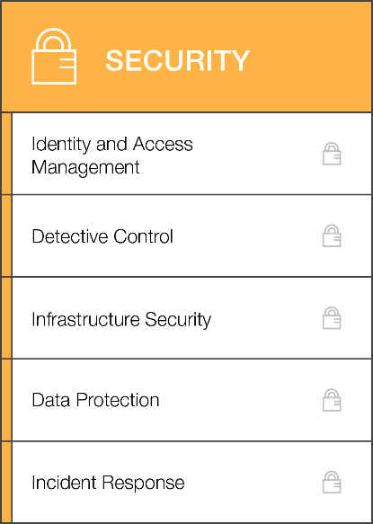The security perspective is focused on managing access and authorizations, compliance, and aligning cloud security controls with current security requirements. During the strategy phase, we should collect all the security requirements, and during the architecture phase, security will need to have a special emphasis, bringing in AWS best practices.

Figure 9 Security Perspective

### Operations Perspective

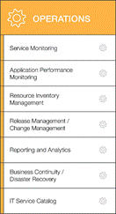The operations perspective is focused on system health and reliability, resiliency, and best practices. These requirements should also be collected during the strategy phase. Then, in the architecture phase, AWS best practices and Kyndryl automation and AIOps capabilities are integrated to provide the best solution for the client.

Figure 10 Operations Perspective

# Aligning our Kyndryl approach with the AWS CAF

The AWS Cloud Adoption Framework (CAF) helps organizations understand how cloud adoption transforms the way they work. It leverages AWS experiences assisting organizations from every segment and every geography with their cloud adoption journey. Figure 11 shows AWS’s approach to cloud adoption.

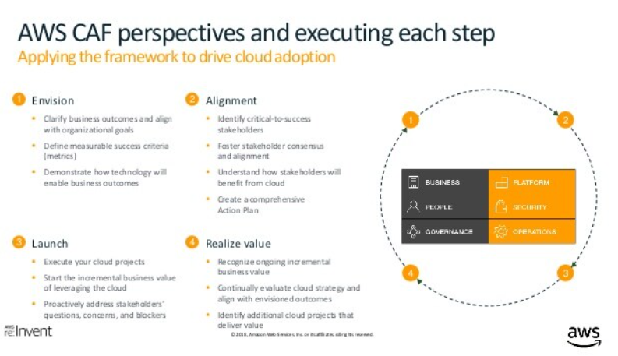

Figure 11: The AWS perspective on driving cloud adoption

It may be necessary to demonstrate to the client or to AWS that we are following their recommended formats. Generally, our Cloud Technology Strategy and Roadmap or Transformation Strategy and Roadmaps engagements are focused around both the Envision and Alignment phases. Our engagements start by gathering current data about the client, analyzing the as-is and define the target state --- resulting in a Transformation Roadmap. This is all aligned with the AWS strategy. Key recommendations

1. We should ensure we are covering most of the perspectives of the CAF
2. We should align our findings, recommendations and initiatives to the CAF perspectives, and ensure our roadmap demonstrates the elements of a successful journey (Figure 12).

This does not mean we need to change our assets and approach. Typically, our engagements add value and much more depth over the topics covered in the CAF. The key to any strategy, is to come up with a comprehensive action plan to realize that strategy, and we codify that in our Transformation Roadmap. It just may be simply that we add a parameter or category that how our findings conclusions, recommendations apply to the CAF dimensions.

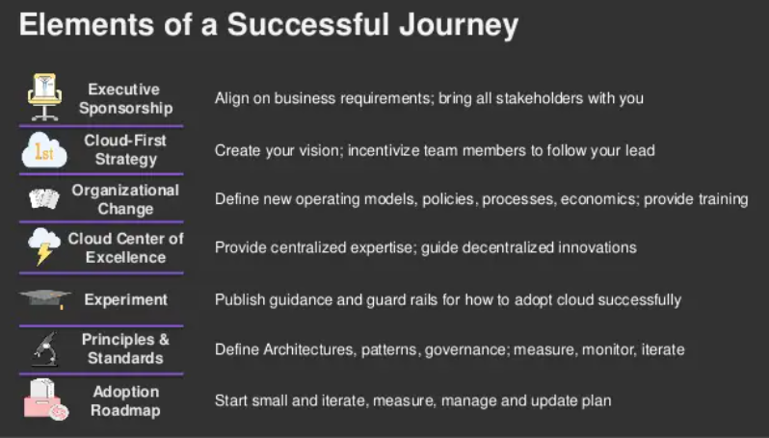

Figure 12: AWS elements of a successful journey

## **Strategy**

### **Gathering input about the client**

Within a TSR engagement you have a series of Application, Infrastructure and Technology Strategy workshops. During data collection, within those workshops, and through interviews much of the information needed to align so the 6 dimensions of the CAF are captured. Many times, our engagements are much more infrastructure related, and we may miss elements of the CAF such as people or governance. If you feel that your data gather is lacking the coverage of the six dimensions, consider the following techniques/tools to capture the information.

1. Tools such as the Migration Readiness Assessment, mentioned in 4.1.3.3 Migration Readiness Assessment (MRA), could be useful in obtaining the clients alignment with the CAF perspectives.
2. Additional techniques such as a design thinking workshop could also be utilized. For example, in an interactive workshop, organized around the CAF perspectives, you can cover items such as

* Challenges
* Stakeholder map
* Hopes and fears
* Empathy maps
* Big ideas and Prioritizations

1. Or depending on the time you have, just produce a SWOT (Strength/Weakness/Opportunity Threat) analysis for each dimension.

* These topics are quite broad, and depending on the audience, can go quite deep – so the real challenge will be in facilitation and keeping the discussion at the same level.
* The ideas coming out of this exercise can be the basis of the roadmap.

### Assessing Application Disposition

It is also critical to determine the workload disposition; what should be done with the workload. AWS uses 7Rs, whereas Kyndryl uses 6Rs – look for an alignment document to be published on this. Each “R” represents a migration strategy. A cost analysis, if required, is part of the assessment phase as well, and further detailed and refined in subsequent phases as required.

#### AWS 7Rs

AWS defines 7 Rs define seven common migration strategies for moving applications to the cloud. These strategies build upon the 5 Rs that Gartner identified in 2011 and consist of the following:

• **Refactor/re-architect.** Move an application and modify its architecture by taking full advantage of cloud-native features to improve agility, performance, and scalability. This typically involves porting the operating system and database.

*Example:* Migrate an on-premises Oracle database to the Amazon Aurora PostgreSQL-Compatible Edition.

• **Re-platform (lift and reshape).** Move an application to the cloud and introduce some level of optimization to take advantage of cloud capabilities.

*Example:* Migrate an on-premises Oracle database to Amazon Relational Database Service (Amazon RDS) for Oracle in the AWS Cloud.

• **Repurchase (drop and shop).** Switch to a different product, typically by moving from a traditional license to a SaaS model.

*Example:* Migrate a customer relationship management (CRM) system to Salesforce.com.

• **Rehost (lift and shift).** Move an application to the cloud without making any changes to take advantage of cloud capabilities.

*Example:* Migrate an on-premises Oracle database to Oracle on an EC2 instance in the AWS Cloud.

• **Relocate (hypervisor-level lift and shift).** Move infrastructure to the cloud without purchasing new hardware, rewriting applications, or modifying your existing operations. This migration scenario is specific to VMware Cloud on AWS, which supports virtual machine (VM) compatibility and workload portability between an on-premises environment and AWS. You can use the VMware Cloud Foundation technologies from the on-premises data centers when you migrate infrastructure to VMware Cloud on AWS.

*Example:* Relocate the hypervisor hosting an Oracle database to VMware Cloud on AWS.

**• Retain (revisit)**. Keep applications in the source environment. These might include applications that require major refactoring, and the client wants to postpone that work until a later time, and legacy applications that the client wants to retain because there’s no business justification for migrating them.

• **Retire.** Decommission or remove applications that are no longer needed in the source environment

#### Kyndryl 7 Rs

|  |  |
| --- | --- |
| Rehost | Move applications without changes. In large-scale, legacy migrations, organizations are looking to move quickly to meet business objectives. (Lift and Shift) |
| Re-platform | Move an application to the cloud and introduce some level of optimization to take advantage of cloud capabilities. You will not change the core architecture of the application. (Lift, Tinker, and shift) |
| Refactor | Reconfigure and refresh the infrastructure, DB, and middleware without a code change. May also include rewriting of one or more components of an application, to take advantage of native cloud services without altering functionality. |
| Re-Architect | Rearchitect and develop an application using cloud-native features to modernize, improve agility, performance, and scalability. |
| Replace | Change to a different product, typically by moving from a traditional application to a software as a service (SaaS) product and migrate data from your on-premises application to the new product. |
| Retain | Keep applications in their current environment. These applications are critical for the business but require major rearchitecting before they can be migrated, or are legacy applications which have no business justification for migrating. |
| Retire | Decommission or remove applications that are no longer needed in your source environment. |

Figure 13 Kyndryl definitions of the76Rs

#### Mapping of AWS dispositions to Kyndryl disposition

Even though there is one less R in Kyndryl definition, we find that they are more granular than AWS’. If the client is very familiar with AWS’ definitions, we can easily remap them and are able to use their terminology.

| **Kyndryl Disposition** | **AWS Disposition** | **Bridge Statement** |
| --- | --- | --- |
| **6 R’s** | **7 R’s** |  |
| **Rehost** | Rehost | Includes Relocate |
| **Refactor** | Refactor / Rearchitect | Split the concepts into two dispositions in Kyndryl  Infra Refactor - config. changes / restructuring of the app code)  Appl Refactor – Taking advantage of native cloud services |
| **Re-platform** | Re-platform | No Change |
| **Rearchitect** | Refactor / Rearchitect | Rearchitect (rewriting the app code) |
| **Replace** | Replace (Repurchase) | Replace with SaaS |
| **Retire** | Retire | No Change |
| **Retain** | Retain | No Change |
| **N/A** | Relocate | Subsumed within Rehost, hence not referred to as a separate line item |

Figure 14 Mapping of Kyndryl dispositions to AWS dispositions

### **AWS tools that support building a strategy**

The [AWS Migration Acceleration Program (MAP)](https://aws.amazon.com/migration-acceleration-program/) is based upon AWS’s experience migrating enterprise customers to the cloud. MAP provides tools that support AWS’s three-phased migration methodology (Assess, Mobilize, and Migrate and Modernize).

More specific to this document, AWS has a series of tools to support building a strategy and a migration plan. We should evaluate on each engagement whether we will utilize these tools or use our Kyndryl tools and approach.

#### **AWS Cloud Adoption Readiness Tool (CART)**

The [Cloud Adoption Readiness Tool (CART)](https://cloudreadiness.amazonaws.com/#/cart) is a self-service readiness assessment tool offered to all clients. It is a short version of the Migration Readiness Assessment (MRA) detailed in the next session.

The AWS Cloud Adoption Readiness Tool (CART) helps organizations of all sizes develop efficient and effective plans for cloud adoption and enterprise cloud migrations. This is a 16-question online survey. Once the client completes a CART survey, the client can provide contact details to download a customized cloud migration assessment that charts readiness and what to do to improve it.

This is a high-level tool, and the results are high level as well. It focuses on cloud migration readiness across the six perspectives including business, people, process, platform, operations, and security. The assessment results include:

* Cloud Adoption Readiness Assessment Summary
* Cloud Readiness Heatmap
* Cloud Readiness Radar chart

**Use of CART on an engagement**

This tool is very lightweight and could be used in a pre-sale effort, a *very short* engagement, or as a predecessor to the MRA.

The MRA is more detailed and preferable for most of engagements and provides more value.

It’s important to determine if you client has already run this tool on their own so that you can preview the results as input into an engagement.

#### **Migration Readiness Assessment (MRA)**

The [Migration Readiness Assessment (MRA)](https://accelerate.amazonaws.com/) process identifies readiness gaps and makes recommendations to fill those gaps in preparation for a large migration effort. This tool is available to AWS partners (Kyndryl is partner), so you will need to log into the Partner Network first.

The MRA is completed interactively in a cross-group setting, involving key stakeholders and team members from across the IT organization, to build a common view of the current state. It consists of 73 questions. Some questions are open ended for written responses; others are to be rated (each also has a comments section).

Much like the CART, the MRA helps you identify gaps along the six perspectives of the AWS Cloud Adoption Framework (business, process, people, platform, operations, and security). This assessment enables you to identify the capabilities required in the migration and build a TCO model for your migration project.

Along with the tool, AWS provides files to help you execute an MRA including the following:

* Offering 1-pager (doc)
* Migration readiness deck (pdf similar to a practitioner guide)
* First call deck and pre-event briefing (ppt)
* Detailed agenda (xls)
* Participant runbook (pdf)
* Questionnaire (xls) – this is a list of all the questions in the tool
* Results review sample (ppt)
* Facilitator runbook (pdf)
* Sponsor runbook (pdf)
* Participant runbook (pdf)
* Workshop delivery (ppt – workshop deck)

We have downloaded these materials and placed them here, but upon engagement please get the latest from the partner network: [Kyndryl Services for AWS - AWS Tools (ibm.com)](https://w3.ibm.com/ocean/w3publisher/kyndryl-aws/aws-tools)

The MRA should be incorporated as the assessment vehicle for any Cloud Technical Strategy and Roadmap engagement or a Transformation Strategy and Roadmap engagement.

There is a pre-assessment questionnaire that you can set up within the tool to go to the sponsor and to participants. This is approximately 14 questions. The tool will keep track of progress and you can analyze the ratings and comments.

AWS suggests that the assessment be 4-6 hours. The ideal scenario is to have everyone in the same room to ensure maximum participation and to enable consensus building.

During the workshop, the tool lets you set up a whiteboard session which the participants log into and either rate or fill in an answer/comment. You analyze the responses and have a discussion on them. The tool will generate the heatmap once complete.



Migration Readiness Assessment heat map



Figure 16 MRA Readiness Assessment Heatmap

The heatmap produced can be information that feeds your roadmap (or as AWS calls it, Action Plan).

**Use of MRA on an engagement**

If there is a client who is planning primarily to go to AWS, this tool is a nice way of capturing the client’s current state and gives you a framework for building the initiatives and recommendations. It covers some questions and areas that we may miss on a completely technology focused approach.

It should be thoroughly investigated and understood if you decide it’s *‘the assessment tool*‘ to be used during the engagement.

#### Application Discovery Service

AWS supports using an application discovery tool. They have their own tool, called the Application Discovery Service (ADS), which is an appliance connecter for virtual services, or agents installed on physical or virtual hosts. Their assessment tools, e.g., the Migration Portfolio Analysis (MPA) tool supports the ingestion of data from other tools like CloudScape.

**Use of ADS on an engagement**

Any discovery that may be a predecessor to migration should be coordinated with the Move/Modernize team. More information can be found here : <https://w3.ibm.com/ocean/w3publisher/cloudmigrationfactory-offerings/capabilities-enablement/target-platforms-guides-handbooks>. Work with your CMM counterpart to determine the best discovery method.

#### Migration Portfolio Analysis (MPA)

The AWS [Migration Portfolio Analysis](https://docs.aws.amazon.com/prescriptive-guidance/latest/migration-tools/migration-tools.pdf) (MPA) is a detailed application portfolio assessment (server right-sizing, pricing, TCO comparisons, migration cost analysis) as well as a migration planning tool (application data analysis and data collection, application grouping, migration prioritization, and wave planning). The service is available free of charge to all AWS consultants and AWS Partner consultants. Log into the Partner Network before using.

Configuration management database (CMDB) and application portfolio data in varied formats can be imported into MPA with a web-based data ingestion process. MPA offers extensive configurability and enables experienced consultants to model customers’ scenarios and generate data for business case analysis and migration planning.

MPA can directly access discovery data from ADS and can import CloudScape (and several other tools) data easily with pre-mapped schema conversions.

The types of things analyzed in the Migration Portfolio Analysis include the following:

* OS currency
* Database distribution
* Grouping of apps by business unit or environment
* Scoring and prioritization based on opportunity, criticality, utilization, and complexity of migration
* Grouping based on the 6rs

The tool enables you to

1. Manage portfolio data

* Import and validate portfolio data with a flexible import workflow and customizable data validation rules.

1. Estimate AWS usage cost

* EC2 type recommendation and cost estimation
* Storage recommendation and cost estimation
* Network cost estimation
* IT labor and support cost estimation

1. Compare AWS and on-premises costs

* See detailed cost and cash flow comparison between AWS and on-premises analysis in both numeric and graphical formats.

1. Estimate migration project cost

* Estimate the cost of an on-premises to AWS migration project.

1. Recommend migration strategies

* Recommend the migration strategy (Rehost, Re-platform, Rearchitect) for the servers and applications in the portfolio.

1. Share analysis

* Share portfolios and collaborate with other MPA users.

1. Collect portfolio data

* Request and collect application, server and database data from the subject matter experts via customizable questionnaires.

1. Prioritize applications

* Rank applications based on the business and technical drivers of the migration.

1. Create application groups

* Create application groups by analyzing dependencies to understand which applications must migrate together.

1. Build a migration wave plan

* Generate a wave plan for application groups. MPA helps to consider an application’s priority, data collection status and dependencies so that migration can start sooner with fewer potential roadblocks.

1. Visualize portfolio

* Visualize the portfolio data through customizable charts.

1. Download assessment

* Download reports in a printable format and to share the analysis and use in presentations.

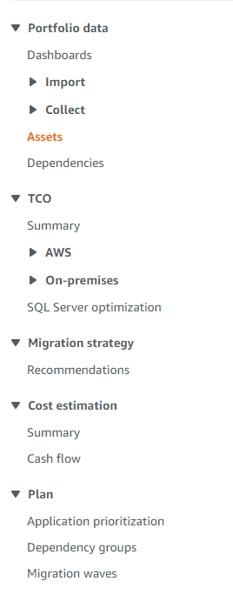

Figure 17 Navigation Pane of the Migration Portfolio Assessment

**Use of MPA on an engagement**

You should think carefully about whether to use the MPA on an engagement. You may want to use a Kyndryl tool like CAT instead of or along with MPA as described in this section.

The three major pieces of the MPA can be covered in different capabilities within our consulting and migration practices. The decision to use MPA may be based on client knowledge of the AWS MPA and the scope of the engagement. You also may want to consider using the MPA alongside our Kyndryl tools/capabilities to compare results.

The three primary areas of the MPA and alternatives are discussed below.

1. Within the MPA, “Migration Strategy” refers to Retain, Retire, Repurchase, Rehost, Re-platform, Rearchitect and Relocate migration patterns. Automated recommendations are based on whether the OS is supported on AWS or not, and include either Rehost, Re-platform, Rearchitect or, (where customer has it set to “on”) Relocate. Users can then manually update (override) the recommendation based on the proposed future architecture. This is a ***very simplistic view*** and tools such as CAT/BlueCAT will give additional insight across the entire portfolio.
2. The MPA will do some level of cost analysis and estimates. If a business case is in scope, the team will have to determine whether we do the CAD business case engagement along with the capabilities here. See the [CAD business case hyperscaler overview](https://kyndryl.box.com/s/yflzuoihdcjixwwnaz29w5hjlgyj8pac).
3. Lastly, the MPA does do affinity grouping and migration waves. We should coordinate with the Move/Modernize team before doing any aspect of migration planning because they might have other tool preferences.

#### Migration to AWS

AWS has migration tools and services or approaches. If migration is in the transformation plan, OR migration is the next step you should coordinate the plan with the Move/Modernize team. There are times it may be appropriate to use AWS tools and services, other times Kyndryl may have a more effective tool or approach. More information can be found on the Move/Modernize site here: <https://w3.ibm.com/ocean/w3publisher/cloudmigrationfactory-offerings/capabilities-enablement/target-platforms-guides-handbooks>. Work with your CMM counterpart to determine the best migration method or service.

#### AWS tool summary

AWS has invested a lot of time and effort in developing tools to help understand the customer’s current environment, project migration costs, etc. Some of these tools are free and others are provided “as a service.” Most of these tools were mentioned in the sections above, this is just a short synopsis of the tools that you may want to look at.

[AWS Prescriptive Guidance](https://docs.aws.amazon.com/prescriptive-guidance/latest/migration-tools/aws-services.html). This site is a tools catalog for accelerating migration with automation. Key tools from a strategy and planning perspective include the following:

1. [AWS Cloud Adoption Readiness Tool](https://cloudreadiness.amazonaws.com/#/cart). Short Assessment open to all. This 16-question online survey and assessment report details your cloud migration readiness across six perspectives including business, people, process, platform, operations, and security.
2. [AWS Migration Readiness Assessment (MRA)](https://accelerate.amazonaws.com/). (*Available with AWS Professional Services and AWS Partner services – free of charge to AWS and Partner consultants.*)
3. [AWS Pricing Calculator](https://calculator.aws/) (*free*). Configures a cost estimate that fits customer needs with AWS products and services.
4. [Migration Portfolio Assessment (MPA).](https://mpa-proserve.amazonaws.com/#/) (*Available with AWS Professional Services and AWS Partner services – free of charge to AWS and Partner consultants.*) Detailed portfolio assessment (server right-sizing, pricing, TCO comparisons, migration cost analysis) as well as migration planning (application data analysis and data collection, application grouping, migration prioritization, and wave planning).
5. [AWS Application Discovery Service](https://aws.amazon.com/application-discovery/) (*An AWS Service*). Collects and presents configuration, usage, and behavior data from servers to help better understand workloads.
6. [Migration Evaluator](https://aws.amazon.com/migration-evaluator/) (Formerly TSO Logic) (*An AWS Service*). Discovers what a customer has on premises, how it's used, and how much it costs to operate—and then determines what the costs would be, with right-sizing, on AWS.

Also reference this document which summarized these tools [AWS Prescriptive Guidance – A tools catalog for accelerating migration and automation.](https://docs.aws.amazon.com/prescriptive-guidance/latest/migration-tools/migration-tools.pdf)

[AWS Cloud Financial Management](https://aws.amazon.com/aws-cost-management/). This site describes the solutions and services dedicated to on-going IT financial management. For example, [AWS Cost Explorer](https://aws.amazon.com/aws-cost-management/aws-cost-explorer/), is a service to help customers understand and manage AWS costs and usage over time

# **AWS approach to architecture**

Turning from strategy to Kyndryl delivery of architecture and design for AWS clients this section outlines adoption and inclusion of required AWS framework elements into our approach. The CAF builds to a target state architecture definition and deployment pattern selection. Architects are expected to deliver an AWS Landing Zone (LZ or control plane), if not already defined, and the target environments. Architecture is focused on being realized through automation and Infrastructure as Code (IaC).

AWS consolidates its approach to architecture and design in the AWS Architecture center. The approach is based on right fit workload deployment, commitment to automation and output as code (IaC). AWS defines architecture through the Well-Architected Framework, its supporting tool for practitioners to validate their designs, leveraging published reference architectures and best practices, plus the requirement for solution architectures to be reviewed and approved by an AWS certified practitioner (this includes any client deliverable). AWS specifies what must be included in a client solution design. As part of Kyndryl providing evidence to maintain or improve our AWS partner status, Kyndryl has produced the [Kyndryl AWS Solution Design Template](https://kyndryl.box.com/s/5jjgdvlmbv7loo0cf59wxmbp5ap5a050) document covering the required aspects which we must also leverage in our engagements.

## **AWS Architecture Center**

The [AWS Architecture Center](https://aws.amazon.com/architecture/) provides reference architecture diagrams, vetted architecture solutions, Well-Architected best practices, patterns, icons, and more. This expert guidance was contributed by AWS cloud architecture experts, including AWS Solutions Architects, Professional Services Consultants, and Partners. The AWS Architecture Center is the home of the Well-Architected Framework, AWS reference architectures and best practices documented in AWS whitepapers. It includes the Well-Architected Lenses and Lab plus the AWS Architecture icons and the AWS Perspective visualization tool. In addition, you can find guidance on various AWS technology categories that you may need to complete your solutions.

For Kyndryl practitioners transitioning from IBM tools it is worth noting that Draw.io is available with an approved AWS Diagram Tool in addition to use of [AWS Perspective](https://aws.amazon.com/solutions/implementations/aws-perspective/). Most Kyndryl work is likely done with Draw.io but clients may require use of AWS Perspective by our teams.

Here you will also find the 'Back to Basics’ video series that explains, examines, and decomposes basic cloud architecture pattern best practices.

Within the Architecture Center you will also fund guidance on [*AWS Cloud Compliance*](http://aws.amazon.com/compliance/?ref=wellarchitected-wp) and resources available in the [*AWS Well-Architected Partner program*](http://aws.amazon.com/architecture/well-architected/partners/?ref=wellarchitected-wp)

## **AWS Well-Architected Framework**

The [AWS Well-Architected Framework](https://aws.amazon.com/architecture/well-architected/?wa-lens-whitepapers.sort-by=item.additionalFields.sortDate&wa-lens-whitepapers.sort-order=desc) describes the key concepts, design principles, and architectural best practices for designing and running workloads in the cloud. By answering a set of foundational questions, you learn how well your architecture aligns with cloud best practices and are provided guidance for making improvements. The prescribed elements constitute a certifiable AWS solution including required organization and process elements architects may be less familiar in covering.

**Table 1. The pillars of the AWS Well-Architected Framework**

| Name | Description |
| --- | --- |
| Operational Excellence | The operational excellence pillar focuses on the ability to support development and run workloads effectively, gain insight into their operations, and to continuously improve supporting processes and procedures to deliver business value. |
| Security | The security pillar describes how to take advantage of cloud technologies to protect data, systems, and assets in a way that can improve your security posture. |
| Reliability | The reliability pillar encompasses the ability of a workload to perform its intended function correctly and consistently when it’s expected to. This includes the ability to operate and test the workload through its total lifecycle. This paper provides in-depth, best practice guidance for implementing reliable workloads on AWS. |
| Performance Efficiency | The performance efficiency pillar addresses the ability to use computing resources efficiently to meet system requirements, and to maintain that efficiency as demand changes and technologies evolve. |
| Cost Optimization | The cost optimization pillar focuses on the ability to run systems to deliver business value at the lowest price point. |

Working with the AWS Well-Architected Framework, practitioners should use these terms:

* A **component** is the code, configuration, and AWS resources that together deliver against a requirement. A component is often the unit of technical ownership and is decoupled from other components.
* The term **workload** is used to identify a set of components that together deliver business value. A workload is usually the level of detail that business and technology leaders communicate about.
* We (practitioners) think about **architecture** as being how components work together in a workload. How components communicate and interact is often the focus of architecture diagrams.
* **Milestones** mark key changes in your architecture as it evolves throughout the product lifecycle (design, implementation, testing, go live, and in production).
* Within an organization the **technology portfolio** is the collection of workloads that are required for the business to operate.

When architecting workloads, you make trade-offs between pillars based on your business context. These business decisions can drive your engineering priorities. You might optimize to reduce cost at the expense of reliability in development environments. For mission-critical solutions, you might optimize reliability with increased costs. In ecommerce solutions, performance can affect revenue and customer propensity to buy. **Security and operational excellence are generally not traded-off against the other pillars.**

The five pillars of the framework are each documented in html and downloadable e-books and supported by accompanying AWS Labs.

[Well-architected framework - further reading](https://docs.aws.amazon.com/wellarchitected/latest/framework/welcome.html)

[*Cost Optimization Pillar whitepaper*](https://docs.aws.amazon.com/wellarchitected/latest/cost-optimization-pillar/welcome.html?ref=wellarchitected-wp)

[*Operational Excellence Pillar whitepaper*](https://docs.aws.amazon.com/wellarchitected/latest/operational-excellence-pillar/welcome.html?ref=wellarchitected-wp)

[*Performance Efficiency Pillar whitepaper*](https://docs.aws.amazon.com/wellarchitected/latest/performance-efficiency-pillar/welcome.html?ref=wellarchitected-wp)

[*Reliability Pillar whitepaper*](https://docs.aws.amazon.com/wellarchitected/latest/reliability-pillar/welcome.html?ref=wellarchitected-wp)

[*Security Pillar whitepaper*](https://docs.aws.amazon.com/wellarchitected/latest/security-pillar/welcome.html?ref=wellarchitected-wp)

[*The Amazon Builders' Library*](http://aws.amazon.com/builders-library/?ref=wellarchitected-wp)

### AWS Well-Architected Lenses

[AWS Well-Architected Lenses](https://aws.amazon.com/architecture/well-architected/?wa-lens-whitepapers.sort-by=item.additionalFields.sortDate&wa-lens-whitepapers.sort-order=desc) extend the guidance offered by AWS Well-Architected to specific industry and technology domains, such as machine learning, analytics, serverless, high performance computing (HPC), IoT (Internet of Things), and financial services. To fully evaluate your workloads, use applicable lenses together with the AWS Well-Architected Framework and the five pillars. Examples include:

* [Management and Governance Lens – AWS Well-Architected](https://docs.aws.amazon.com/wellarchitected/latest/management-and-governance-lens/management-and-governance-lens.html?did=wp_card&trk=wp_card)
* [Financial Services Industry Lens – AWS Well-Architected](https://docs.aws.amazon.com/wellarchitected/latest/financial-services-industry-lens/welcome.html?did=wp_card&trk=wp_card)

## **AWS Well-Architected (WA) Tool**

Use the WA Tool to validate your work. The [AWS Well-Architected Tool](https://aws.amazon.com/well-architected-tool/?whats-new-cards.sort-by=item.additionalFields.postDateTime&whats-new-cards.sort-order=desc) helps you review the state of your workloads and compares them to the latest AWS architectural best practices. The tool is based on the [AWS Well-Architected Framework](https://aws.amazon.com/architecture/well-architected/), developed to help cloud architects build secure, high-performing, resilient, and efficient application infrastructure. This framework provides a consistent approach for customers and partners to evaluate architectures, has been used in tens of thousands of workload reviews conducted by the AWS solutions architecture team, and provides guidance to help implement designs that scale with application needs over time.

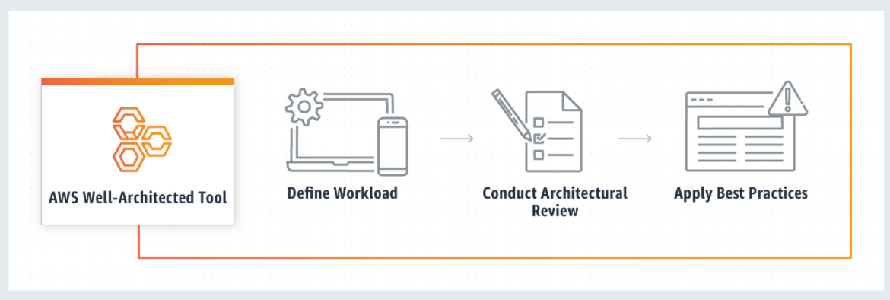

Figure 18 AWS Well-Architected Tool - how it works

To use this free tool, available in the AWS Management Console, just define your workload and answer a set of questions regarding operational excellence, security, reliability, performance efficiency, and cost optimization. The AWS WA Tool then provides a plan on how to architect for the cloud using established best practices.

Note: You can use this link to access from the console if you have an account: <https://console.aws.amazon.com/wellarchitected>

## **AWS reference architectures and best practices**

[AWS reference architectures](https://aws.amazon.com/architecture/reference-architecture-diagrams/?whitepapers-main.sort-by=item.additionalFields.sortDate&whitepapers-main.sort-order=desc&awsf.whitepapers-tech-category=*all&awsf.whitepapers-industries=*all) are available for download copy and reuse. These are vetted designs published for community reference and are more formally curated than any available on the “My Architecture” page.

Reference architectures are both component or function level sub-systems and fuller solutions. Examples of reference architectures include:

* [AWS CloudEndure Migration Factory Solution](https://d1.awsstatic.com/architecture-diagrams/ArchitectureDiagrams/aws-cloudendure-migration-factory-solution-sol.pdf?did=wp_card&trk=wp_card)
* [VMware Cloud on AWS – Networking Reference Architectures](https://d1.awsstatic.com/architecture-diagrams/ArchitectureDiagrams/vmware-cloud-on-aws-networking-ra.pdf?did=wp_card&trk=wp_card)
* [Veeam Backup on VMware Cloud on AWS](https://d1.awsstatic.com/architecture-diagrams/ArchitectureDiagrams/veeam-repository-backup-vmware-on-aws.pdf?did=wp_card&trk=wp_card)
* [Modernize Applications with Microservices Architecture using Amazon Elastic Kubernetes Service (Amazon EKS)](https://d1.awsstatic.com/architecture-diagrams/ArchitectureDiagrams/modernize-applications-with-microservices-using-amazon-eks-ra.pdf?did=wp_card&trk=wp_card)

AWS publishes a series of best practice whitepapers and technique papers that should be leveraged to improve AWS solution designs and ensure our designs conform to certification criteria. Useful guides include:

* [SDDC Deployment and Best Practices Guide on AWS](https://d1.awsstatic.com/whitepapers/sddc-deployment-and-best-practices.pdf?did=wp_card&trk=wp_card)
* [Change Management in the Cloud](https://docs.aws.amazon.com/whitepapers/latest/change-management-in-the-cloud/change-management-in-the-cloud.html?did=wp_card&trk=wp_card)
* [Building an AWS Perimeter](https://d1.awsstatic.com/whitepapers/building_an_aws_perimeter.pdf?did=wp_card&trk=wp_card)

## Aligning our cloud architecture offering to AWS

As noted above Kyndryl has introduced measures to ensure alignment to the AWS process and maintenance of our partner status. There are 3 main elements to this:

* The [Kyndryl AWS Solution Design Template](https://kyndryl.box.com/s/pjxdjrlx8jjbr6r862u1iys1gpg1p3o7) - this should be familiar to any Team Solution Design (TSD) practitioner (temp link to draft; expect production copy to be accessed via Git below).
* The audit requirement to demonstrate peer review of solution designs by AWS Certified practitioners
* The Kyndryl AWS architecture review board established to support the required peer review. Long term this will be primarily for large deals but while practices are organizing and staffing it is available to our practitioners for review of their designs. <https://pages.github.kyndryl.net/OCTO/aws/solutions-guidance/expert-design-review/01-design-review-intro/>

In addition to these resources Kyndryl has produced a compilation of AWS services and architecture diagrams to advance practitioner understanding and solutioning including these services.

### Client engagement example

In conjunction with field practitioners, Kyndryl has produced an initial AWS Landing Zone design based on a real client solution engagement. This is intended to be the first in a series of reference designs available for practitioners and solutioners; it covers at least the high-level design aspects. These reference designs should be the starting point for any Kyndryl AWS architecture because they reflect certification needs, deal solutioning needs and subsequent practitioner design in delivery. The sample solution in “Cloud Solution Board” (CSB) format is available here: <https://kyndryl.box.com/s/em724byaw9fswargnawtilcyiujlyw5c>

Content includes a sample CSB solution review document (non-AWS solution), Kyndryl AWS default active/passive architecture, Bill of Materials (BOM) and requirements checklist.

### AWS repository

The Kyndryl technical community has documented in GitHub aspects of AWS and other hyperscaler architectures and services. A primer on hyperscaler comparison can be found here together with architecture diagrams of the documented AWS services:

<https://gzeien.github.io/cloud-notebook/basics/cloud-provider-service-summary/>

The primary author Gary Zeien also recommends the following site for further hyperscaler comparison:

<https://comparecloud.in/>

As Kyndryl Hyperscaler Tiger Team materials become more available we will update linkages in this document.

AWS materials start here: <https://gzeien.github.io/cloud-notebook/cloud-aws-cloud/Purpose/>

Within the repository you will find materials on organisation and account design, security architecture, compute and storage, networking, and individual services such a containers or caching. While the pages do not include architecture decisions, they do reference how the services are constructed and integrated providing insight on capabilities and limitations that would impact use in any solution.

### Infrastructure as Code (IAC) tools

In addition to these it should be noted that AWS - and indeed other hyperscalers - promote or demand the realization of architecture through automation and CI/CD pipeline integration. To that end the emphasis must be on delivering design elements as code – leveraging CSP approved IAC tools. For AWS that is primarily its own AWS CloudFormation and Terraform.

For a general introduction to IaC and hyperscaler approaches please see this CAD [Introduction to IaC](https://kyndryl.box.com/s/cg0zq9rdvm6a68eji1jewixcs7lxbynx) for additional information.

**Important:**

Overall AWS accepts the current Kyndryl Team Solution Design approach to architecture method and documentation. However, it is fundamental to our status as an AWS partner that practitioners designing AWS solutions adopt the Well-Architected Framework and associated supports; and, integrate those required elements into the overall architecture and the provided solution design template.